**DAILY ONLINE ACTIVITIES SUMMARY**

|  |  |  |  |  |  |  |  |  |
| --- | --- | --- | --- | --- | --- | --- | --- | --- |
| **Date:** | **06/07/2020** | | | | | **Name:** | **NAIPUNYA VINOD NAIK** | |
| **Sem & Sec** | **IV SEM & A SECTION** | | | | | **USN:** | **4AL18CS050** | |
| **Online Test Summary** | | | | | | | | |
| **Subject** | | **COMPLEX ANALYSIS,PROBABILITY AND STATISTICAL METHODS** | | | | | | |
| **Max. Marks** | | **30** | | **Score** | | | **-----------------** | |
| **Certification Course Summary** | | | | | | | | |
| **Course** | **1) WEBINAR ON BECOME JOB READY FOR ADMIN/DEVELOPER**  **2) WEBINAR ON HOW TO USE REMOTE INTERNSHIP OPPORTUNITIES**  **3) C++ PROGRAMMING STEP BY STEP FROM BEGINNER TO ULTIMATE LEVEL** | | | | | | | |
| **Certificate Provider** | | | **1) AIET**  **2) AIET**  **3) UDEMY** | | **Duration** | | | **1) 1HR**  **2) 1 HR**  **3) 11.5 HR** |
| **Coding Challenges** | | | | | | | | |
| **Problem Statement: 1)** [Write a Java program to find the Nth natural number with exactly two bits set](https://github.com/orgs/alvas-education-foundation/teams/2nd-year/discussions/146). | | | | | | | | |
| **Status: EXECUTED** | | | | | | | | |
| **Uploaded the report in Github** | | | | | **YES** | | | |
| **If yes Repository name** | | | | | <https://github.com/naipunya-naik/lockdown-coding/blob/master/JAVA%20CODING/NumberBit_06-07-2020.java> | | | |
| **Uploaded the report in slack** | | | | | **YES** | | | |

Online Test Details: (Attach the snapshot and briefly write the report for the same).

* TODAY COMPLEX ANALYSIS, PROBABILITY AND STATISTICAL METHODS DESCIPTIVE TEST WAS CONDUCTED ON 06 JULY 2020.
* DURATION:- 45 MIN
* TOTAL MARKS:- 30
* NO.OF QUESTIONS:- 3
* 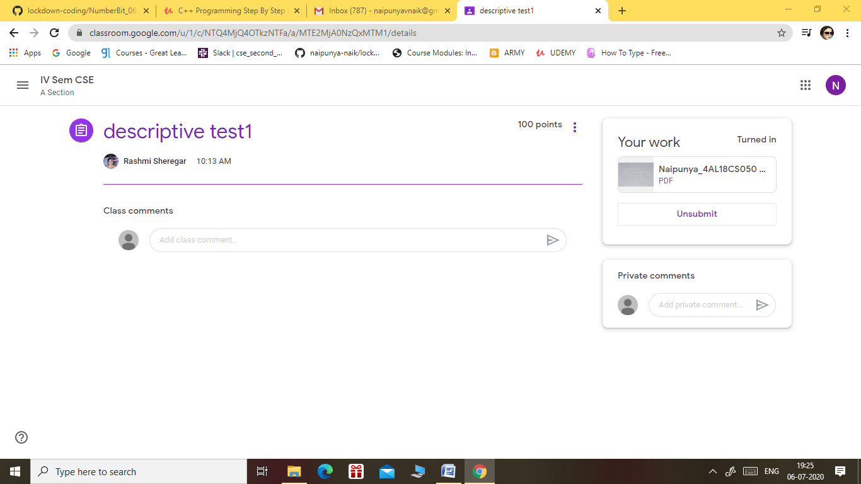
* FROM 9.30 AM TO 10.15AM
* MARKS ARE WILL BE DECLARED SOON.

Certification Course Details: (Attach the snapshot and briefly write the report for the same).

1) **WEBINAR ON BECOME JOB READY FOR ADMIN/DEVELOPER**

**CONDUCTED BY:- NEETU BANSAL, MANASWI PAUSKAR ,AVIRAL AGARWAL IN COLLABORATION WITH AIET.**





2) **WEBINAR ON HOW TO USE REMOTE INTERNSHIP OPPORTUNITIES.**

**CONDUCTED BY:- TCS ION IN COLLABORATION WITH AIET**



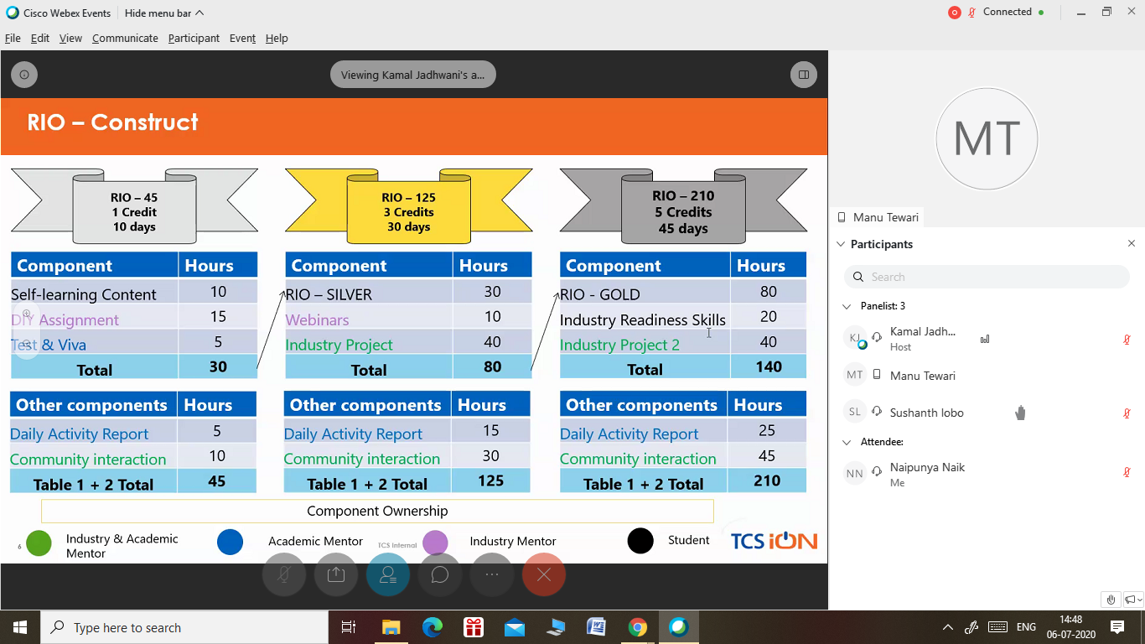

3) CERTIFICATION COURSE NAME:- C++ PROGRAMMING STEP BY STEP FROM BEGINNER TO ULTIMATE LEVEL 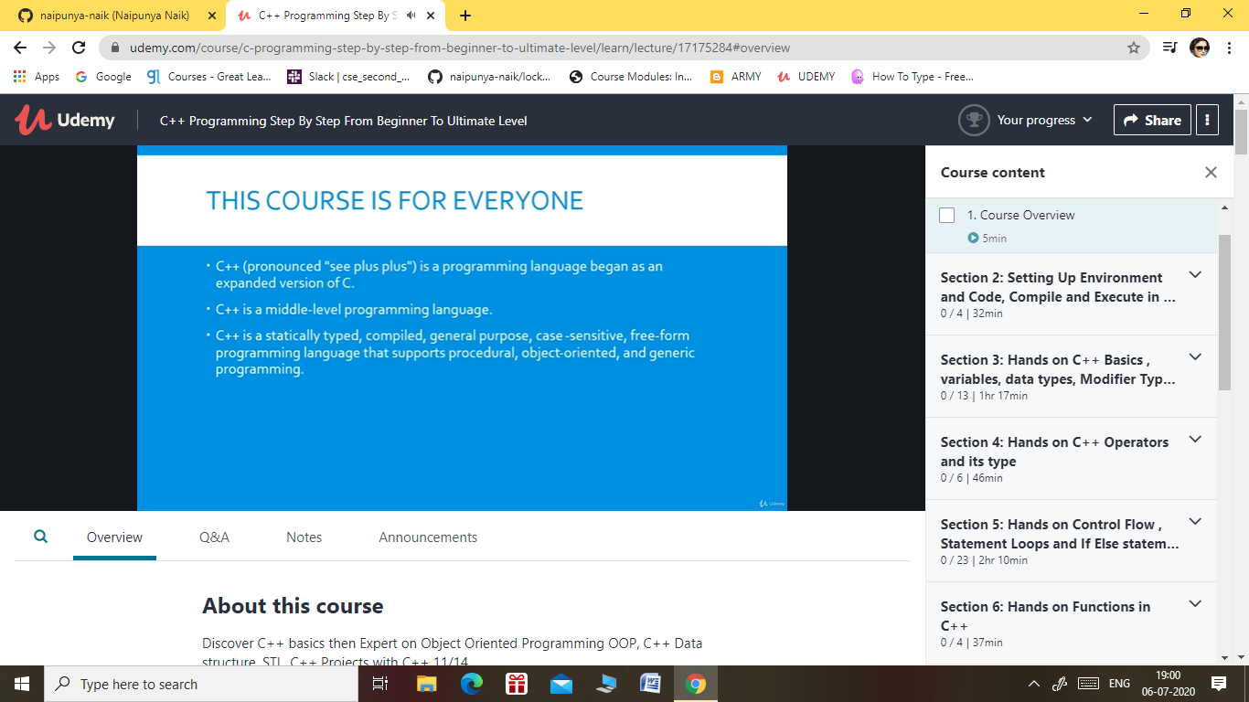

TOPICS LEARNT ON 6 JULY 2020:-

**Introduction**

* Introduction

**Setting Up Environment and Code, Compile and Execute in different IDE**

* Hands on Download and Install First IDE Code::Blocks
* Hands on Download and Install 2nd IDE Dev-C++
* Understand Our first program and prints <Hello World> - 1
* Understand Our first program and prints <Hello World> - 2

**Hands on C++ Basics , variables, data types, Modifier Type Casting Etc**

* Comprehend C++ DataType Concept
* Comprehend C++ Variables that how variable store Memory
* C++ Data Type Concept and Variable together
* Hands on C++ Reference Variable how we use It
* Comprehend C++ program which takes User Input from Keyboard
* Understand the C++ Input and Out Streams
* C++ Type Casting / Type Convention and types
* Constant and literal in C++ #1
* Constant in C++ #2
* Modifier and its type in C++ #1
* Modifier and its type in C++ #2

**Hands on C++ Operators and its type**

* All in one C++ Operator and its type
* Hands on Increment ++ and Decrements -- Operators in C++
* Arithmetic Operator in C++
* C++ the size of comma and Conditional operator
* Relational Operators in C++
* Logical And, logical or <and> logical not Operator

Coding Challenges Details: (Attach the snapshot and briefly write the report for the same).

PROBLEM STATEMENT:- Write a Java program to find the Nth natural number with exactly two bits set.

Top of Form

Bottom of Form

|  |
| --- |
| Given an integer N, the task is to find the Nth natural number with exactly two bits set.  Examples:  Input: N = 4 Output: 9  Input: N = 15 Output: 48  **Hint** **Explanation: of 1st example** Binary representation of numbers 1 -0001, 2- 0010, **3- 0011**, 4-0100, **5-0101**, **6-0110**, 7- 0111, 8-1000, **9 - 1001**, **10- 1010** etc. Here only for the bold numbers binary values contains exactly 2 bits 1's hence Numbers with exactly two bits set: 3, 5, 6, 9, 10, 12, … 4th number in this is 9.  **Therefore output is 9** |

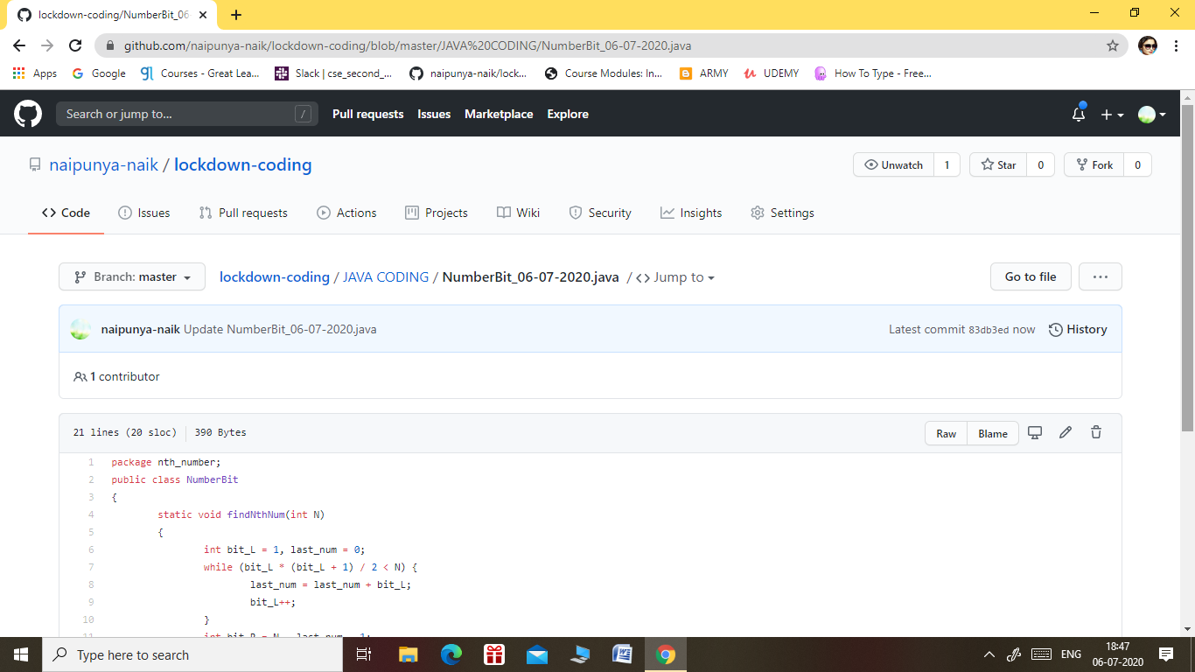

GITHUB REPOSITORY LINK:-

<https://github.com/naipunya-naik/lockdown-coding/blob/master/JAVA%20CODING/NumberBit_06-07-2020.java>